MISSION STATEMENT

The mission of Purdue Testing Services (PTS) is to serve instructors, students and the greater Purdue community by providing testing services for undergraduate advancement, graduate development and professional accreditation. The primary role of PTS is to support instructors and students through the accommodated testing process in partnership with the Disability Resource Center (DRC).

VISION STATEMENT
PTS is responsive to the needs of campus and provides on-time, quality support to facilitate the completion of exams. We aspire to be viewed as experts in our field by campus partners and other institutions.

PROGRAM ELEMENTS
PTS offers a suite of exams that include:
- Accommodated Academic Exams
  - Print, package and administer academic exams on behalf of instructors for students with approved accommodations through the DRC.
  - Facilitate the full spectrum of testing accommodations including extended time, distraction-reduced environment, assistive technology, music during exams and alternate furniture.
- Pearson Exams
  - Evaluation Systems Exams (ES)
    - Teacher licensure exams
  - Executive Assessment (EA)
    - Business school readiness exam
  - Graduate Management Admission Test (GMAT)
  - Fundamentals of Engineering (FE) and Fundamentals of Surveying (FS)
    - Engineer licensure exams
  - Microsoft Certification (Microsoft)
    - Specialist and technical certification exams
  - Air Force Officer Qualifying Test (AFOQT)
- ETS
  - Praxis
    - Teacher licensure exams
  - Graduate Record Examinations (GRE – General)
- College Board
  - College-Level Examination Program (CLEP) is a series of exams that allow for credit by exam.
  - There are a total of 33 exams across the following categories: Composition and Literature; World Languages; History and Social Science; Science and Mathematics; and Business.
- Purdue Advanced Credit
  - Chemistry, Computer Science, and Computer & Information Technology (CNIT)

PROGRAM GOALS
- Every client has a satisfactory experience, including students taking accommodated exams, clients taking vendor exams and instructors who utilize PTS services.
- Accommodated testing capacity is used more efficiently and effectively. This capacity is defined as space, staffing and time resources.
- Instructors fully understand their role and choices regarding accommodated testing.
- The university community becomes more aware of the variety of services offered by PTS, increasing the overall number of exams proctored.
- A robust communication plan is developed to ensure consistent messaging and marketing to all constituents.
- All processes and procedures are fully documented.

NOTABLE CHANGES FROM 2024-25 ACADEMIC YEAR

Organizational and Operational Achievements
- Secured a five-year agreement with the Purdue Memorial Union (PMU) and Registrar to guarantee use of Stewart Center’s (STEW) second-floor rooms for accommodated final exam administration.
- Partnered with the Registrar to reserve STEW 314 and 320 nightly as additional proctoring spaces, increasing nightly seat capacity from 79 to 151.
- Proactively collaborated with the Registrar and the Center for Instructional Excellence (CIE) to identify dates with high demand for accommodated testing. By analyzing scheduling patterns and peak exam times, PTS anticipated increased testing needs and implemented solutions such as reserving extra spaces and utilizing a trained proctor pool. PTS also partnered with academic departments and emailed instructors before the start of each semester to share projected peak testing dates, helping faculty plan in advance and minimize scheduling conflicts.
- Completed an internal restructure to align staff positions more closely with operational needs. Three existing positions were redesigned, resulting in the creation of a salaried Operations Manager role and two 10-month hourly positions — Testing Services Administrator and Administrative Assistant. Transitioning these positions to 10-month appointments better matched staffing levels with summer service demands while maintaining operational efficiency.
- Expanded vendor testing services by purchasing additional computers, increasing ETS and Pearson exam seat capacity from 14 to 20. Dedicated student proctors were hired to ensure compliance with ETS in-room staffing requirements, improving efficiency and allowing full-time staff to focus on critical administrative responsibilities.
- Added the Air Force Officer Qualifying Test (AFOQT) to its PearsonVue offerings in partnership with the ROTC program. This required completing PearsonVue’s certification process, strengthening both PTS’s testing portfolio and its collaboration with campus partners.
- Collaborated with RegisterBlast to implement several system enhancements, including a new bulk exam coversheet printing feature that consolidates accommodation details, appointment information, and instructor instructions into a single document. This improvement streamlined exam preparation and reduced potential for human error.
- Established an internal proctor pool of trained student staff specifically for finals week, improving efficiency, increasing coverage, and enhancing exam administration during peak periods.
- Analyzed campus-wide demand for accommodated testing, identified unmet needs, and submitted findings to university leaders to inform future planning and resource allocation.

Staff and Professional Highlights
- Bahiyyih Baker was promoted from Senior Test Administrator to Assistant Director, Vendor Testing in April 2025.
- PTS welcomed several new team members as part of the office restructure:
  - Gail Dick, Administrative Assistant (April 2025)
  - Dave Oney, Operations Manager (June 2025)
  - Emily Phillips, Testing Services Administrator (August 2025)
- PTS leadership attended the National Collegiate Testing Association (NCTA) Conference in July 2025. Director Kelsey Jordan presented three sessions:
  - Accommodated Testing Demystified: Ask the Experts
  - Leveraging Collaboration: Insights from the Big Ten Academic Alliance Testing Group
  - Special Interest Group (SIG) Coffee Date
- Kelsey Jordan was elected to the NCTA Governing Council for a three-year term, providing leadership and oversight for the organization’s Professional Services Division.
PROGRAM ASSESSMENT
- Initiate the use of a survey to collect and analyze data on the population served by vendor-based exams to inform service decisions, while actively investigating strategies to enhance the quality, reach, and effectiveness of PTS user feedback methods.
- Explore and evaluate the experience of instructors who utilize PTS to administer accommodated exams to improve services (e.g. end-of-semester surveys and focus groups). For example, how does PTS measure instructor satisfaction?
- Use available data to better understand the use of staffing, space and time resources.
- Determine the need for vendor exams at Purdue and if there are some vendor exams PTS is not offering but should be.
- Measure the effectiveness of communications with each constituent through the use of web analytics and data from an email campaign tool.

OUR DATA
See attached data summary.

ACCOMMODATED ACADEMIC EXAMS TESTING

Students with Active Testing Accommodations vs. Accommodated Students Proctored in PTS
The bar graph below provides a comparative analysis of the total number of unique students with active testing accommodations who shared their course accommodation letters (CALs) through the DRC versus the number of those students who took at least one exam with PTS from Fall 2022 to Spring 2025. The data illustrates a consistent increase in both students with active accommodations and those who took exams with PTS over the academic terms. Fall 2024 shows the highest number of those with active testing accommodations (2,623 students) and proctored exams (1,909 students).

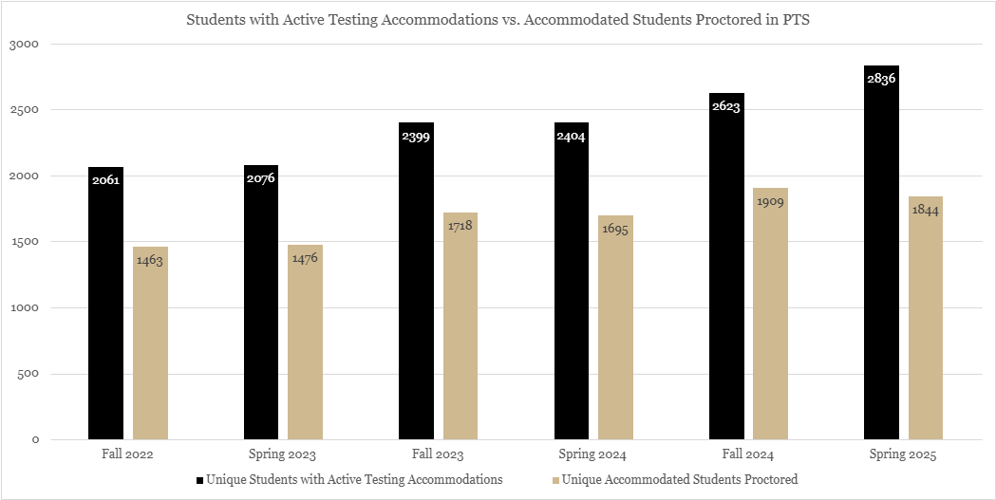

Accommodated Academic Exams Administered by PTS
The line graph below illustrates the number of accommodated academic exams administered by PTS across various academic terms from Fall 2022 to Spring 2025, broken down by week. The data shows a consistent increase in exam administration volume as each term progresses, particularly peaking around Weeks 9, 13 and Finals Week. This reflects the predictable exam schedule of university courses, with the highest demand for accommodated academic exams occurring during final exams. The trend lines across different terms display a similar pattern, with each semester starting at a low volume of exams administered in the early weeks, followed by a sharp increase leading to a spike during final exam periods. The overall upward trend over the years highlights the university’s growing reliance on PTS to administer accommodated academic exams as student needs continue to expand.

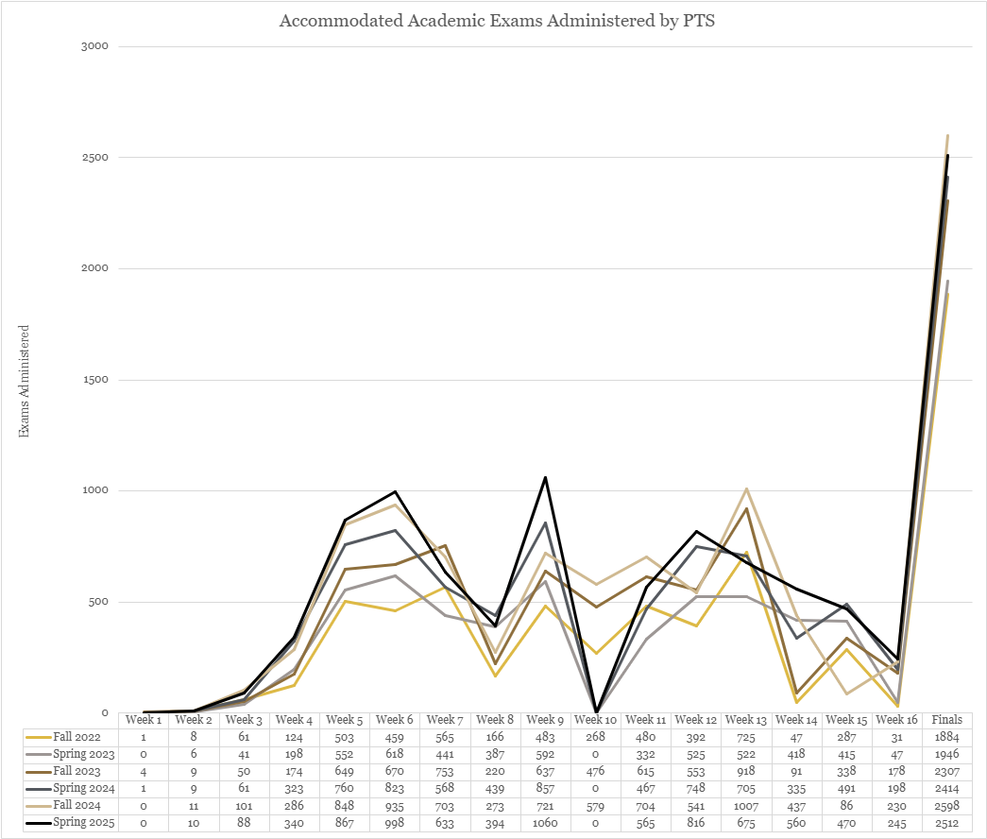

Individual Exams Printed vs. Individual Exams Administered
The bar graph below compares the total number of individual exams printed versus individual exams administered by PTS from Fall 2022 to Spring 2025. The data presented does not represent unique exams, but the total number of exams processed for students across each term. It demonstrates a steady increase in both printed and administered exams over time, with Fall 2024 and Spring 2025 showing the highest volumes — highlighting a significant demand for printing services within PTS.

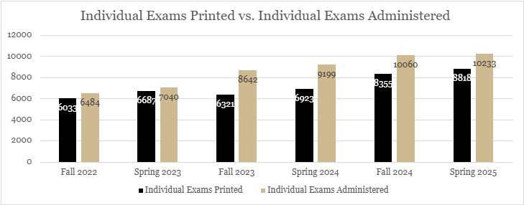

Unique Courses and Instructors Utilizing PTS
The bar graph below illustrates the number of unique courses and instructors utilizing Purdue Testing Services (PTS) for exam administration from Fall 2023 through Spring 2025. The data shows a steady increase in both categories, with the number of courses growing from 493 to 531 and instructors from 517 to 554.

For reporting purposes, a unique course is defined as an individual course, which may have multiple sections or instructors associated with it. Instructors are defined as individuals who submit the TIFs which may teach one or more courses in a given term and/or be a course coordinator submitting on behalf of the actual instructor.

Total Accommodated Exams Administered
The line graph below shows the total number of accommodated exams proctored by Purdue Testing Services (PTS) from the 2018–19 academic year through 2024–25. A significant decline is visible in 2020–21, when the number of accommodated exams dropped to 2,272 due to the COVID-19 pandemic and the campus-wide shift to remote instruction. Since then, the number of accommodated exams has rebounded steadily each year, reflecting both the return to in-person learning and increased utilization of PTS services. Most notably, the number of accommodated exams reached a record high of 20,293 in 2024–25 — more than eight times the total during the pandemic year. This sustained upward trend underscores the growing demand for accommodated testing on campus and highlights the essential role PTS plays in supporting instructors in administering their exams for students with accommodations.

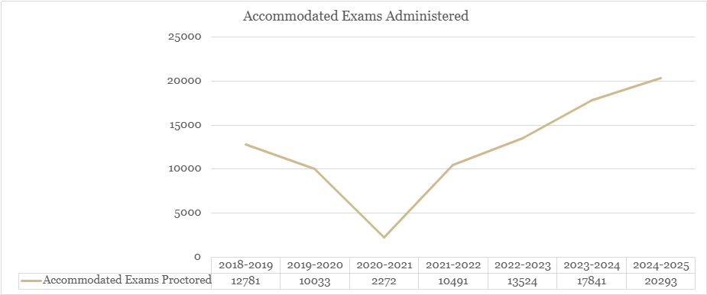

PTS relocated to expanded testing facilities in Stewart Center G59 beginning in Fall 2020 and G39 in May 2023 which increased seating capacity and contributed to subsequent growth in accommodated exam volume.

VENDOR & ADVANCED CREDIT EXAM DATA
The bar graph below provides a comparison of advanced credit and external vendor testing volumes administered by Purdue Testing Services (PTS) over the last four academic years (2021–22 through 2024–25). The data highlights the wide variety of exams offered, including the FE, GMAT, Microsoft, Praxis, GRE, CLEP, and Purdue’s own Chemistry (CHM) and Computer Science (CS 159) advanced credit exams. In Spring 2025, PTS added CNIT exams to its offerings, contributing to a notable increase in advanced credit testing. Significant growth was also seen in both the FE and CLEP exams, with FE rising from 9 in 2021–22 to 402 in 2024–25, and CLEP increasing from 175 to 387 during the same period. These increases reflect PTS’s expanded testing schedule and the addition of more testing dates for external vendor exams, which has enhanced accessibility and better met student demand. Although some exams, such as GMAT, continue to see lower volumes compared to previous years, the overall upward trend underscores PTS’s adaptability and continued growth in facilitating a broad range of credentialing and credit opportunities across disciplines and testing providers.

PTS expanded vendor testing capacity in May 2023 by adding additional testing stations, contributing to increased exam volumes in subsequent years.

